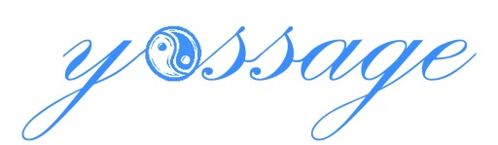 presents:

**Lavender Zen Body Scrub**

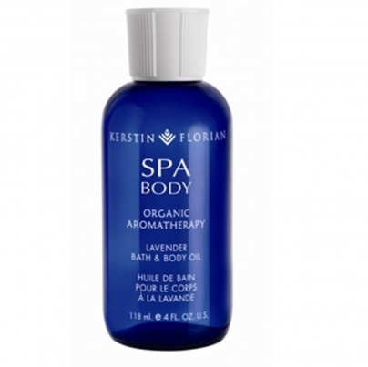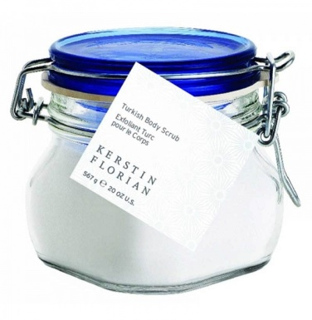Using  products, a company whose guiding philosophy of Outer Beauty, Inner Health inspires a sense of wellbeing through powerful plant, marine and technically-advanced ingredients as well as professionally-designed spa services.

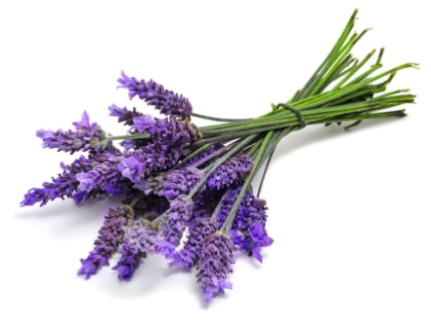

Remedy jet lag, stress induced tension, or your shortage of sweet slumber in this balancing spa experience that includes a dry brush exfoliation, full body exfoliation with our Turkish Body Scrub infused with organic essential oil to energize your mind and body or to promote deep relaxation. Our soothing Lavender induces rest and melts the stress away. You also have the option to choose whether or not you would like soothing eucalyptus included in your treatment. Mini massage included after the scrub is complete. 60 min. $110

